# IN501 Databases 2

# Data Model Assignment

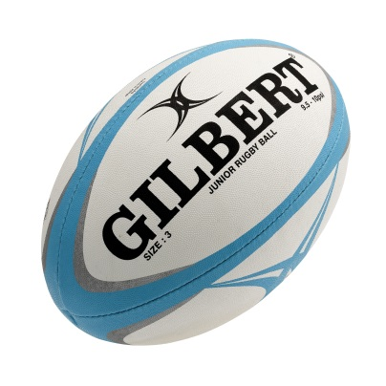

Adam Charlton

8 May 2013

# Main Objective:

The main objective for the database will be able to handle the entire registration and re- registration of players and example of this will be entering the new players and then getting the information from the union to confirm that the players information is correct.

It will be used to track the assignment of teams, hold the registration from contact details however also being able to track the teams gear this will include the coaches track suit and a gear bag that could hold several items such as a first aid kit, training cones, bibs and balls.

The teams are based on the ages of the children and play a different style of game

The shop roster will also be recorded and which team is manning the shop this is based on which team has home games.

A record of the keys for the ground while be recorded and a associated list of restricted persons allowed access to the keys.

The system will be able to record the teams game scores and season results also track awards that the teams receive, awards such as end of season Most Valuable Player and Most Improved Player and for each game the player of the day will be recorded.

The database will be able to link all the children with parents this is for contact reasons and resolve the issue of sending multiple forms and details to the same family.

Some aspects noted that are not in the scope of this database is the tracking of the inventory, it is far to complex. This can be made separately and then coupled with this database at a later date.

Once the database is finished the information that a user will be able to access is the writing of the weekly newsletter, print a mail merge to be published to the website and generate reports for the end of season and staffing purposes.

# Use Cases:

* 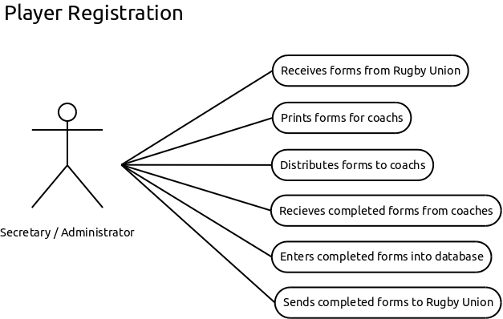
* 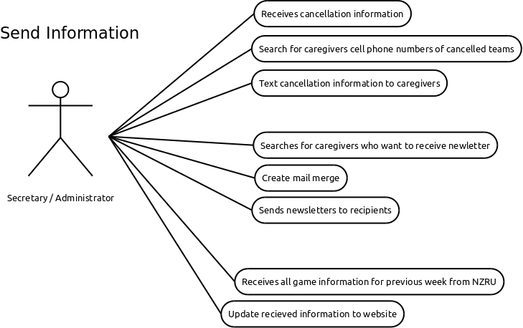
* 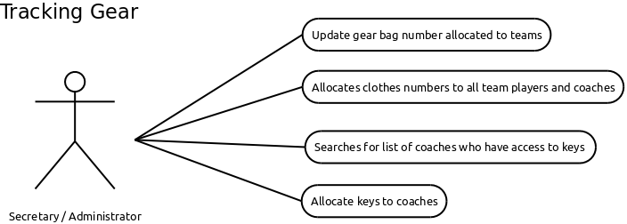
* 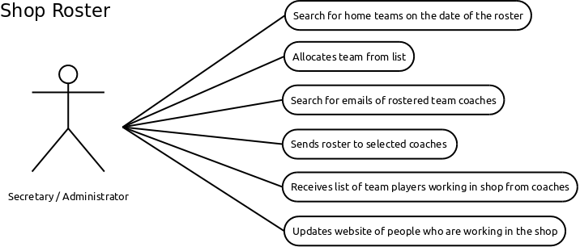

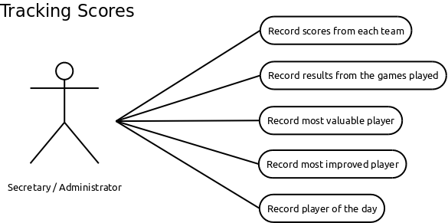

# Data Model:

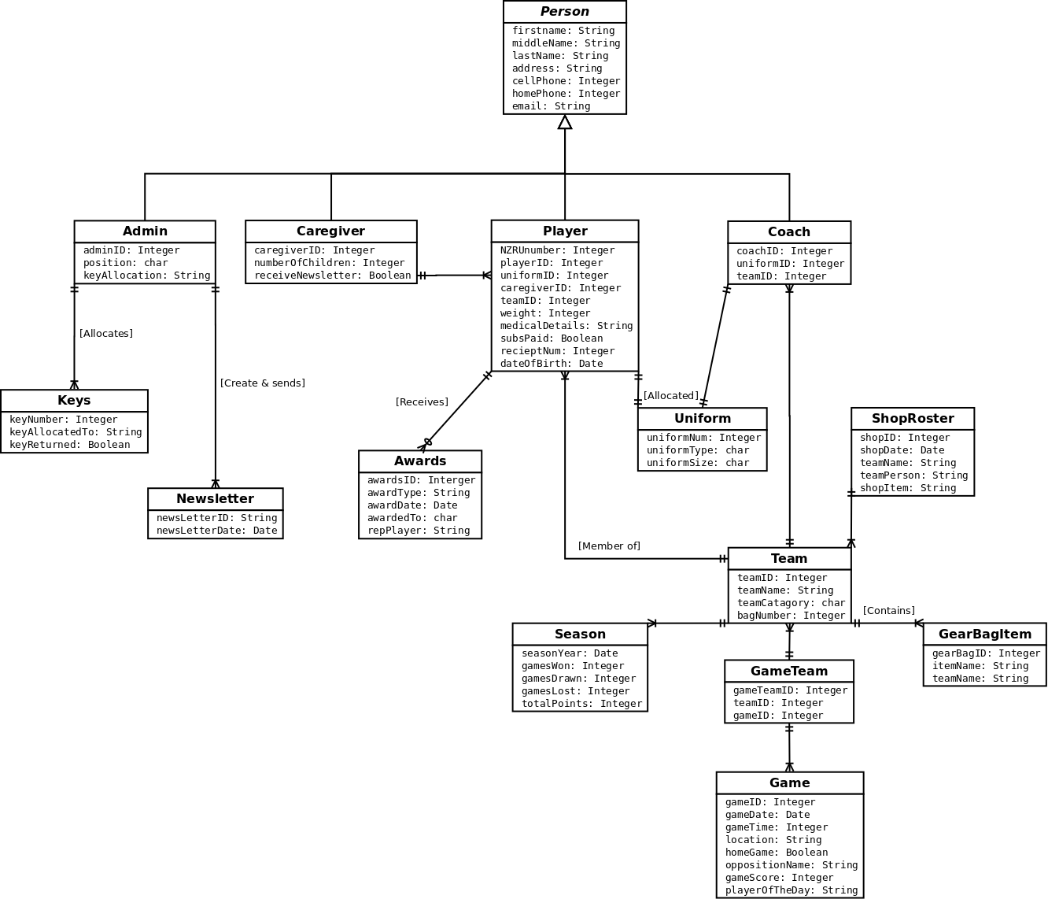

# Data Dictionary:

|  |  |  |  |
| --- | --- | --- | --- |
| **Table** | **Attribute** | **Data Type** | **Description** |
| ***Person*** |  |  | *Abstract Class* |
|  | firstName  middleName  lastName  address  cellPhone  homePhoneNum  email | String  String  String  String  Integer  Integer  String | First Name  Middle Name  Last Name  Address  Cell number  Home number  Email address |
| **Coach** |  |  |  |
|  | coachID  uniformID  teamID | Integer  Integer  Integer | Primary key  Coaches qualifications  Coach referee date |
| **Player** |  |  |  |
|  | NZRUNumber  playerID  uniformID  caregiverID  teamID  weight  medicalDetails  subsPaid  receiptNum  dateOfBirth | Integer  Integer  Integer  Integer  Integer  Integer  String  Boolean  Integer  Date | Primary key  Foreign key  Foreign key  Foreign key  Foreign key  Weight of player  Medical details of player  Has the subs been played  Receipt for players sub  Date of birth |
| **Admin** |  |  |  |
|  | adminID  position  keyAllocated | Integer  char  String | Primary key  Staff position e.g. “Secretary”, “Treasurer”  Allocated person |
| **Caregiver** |  |  |  |
|  | caregiverID  numberOfChildren  receiveNewLetter | Integer  Integer  Boolean | Primary key  Number of children that are players  Would like to receive a newsletter |

|  |  |  |  |  |
| --- | --- | --- | --- | --- |
| **Team** | |  |  |  |
|  | | teamID  teamName  teamCategory  bagNumber | Integer  String  char  Integer | Primary key  Name of the Team  Category of team e.g. “Age”, “Weight”  Allocated gear bag number |
| **Season** |  |  |  |
|  | seasonYear\  gamesWon  gamesDrawn  gamesLost  totalPoints | Date  Integer  Integer  Integer  Integer | Primary key  How many games won  How many games drawn  How many games lost  Total points over the season |
| **GameTeam** |  |  |  |
|  | gameTeamID  teamID  gameID | Integer  Integer  Integer | Primary key  Foreign key  Foreign key |
| **Game** |  |  |  |
|  | gameID  gameDate  gameTime  location  homeGame  oppositionName  gameScore  playerOfTheDay | Integer  Date  Integer  String  Boolean  String  Integer  String | Primary key  Date of game  Time of game  Location of game  Is game HOME | AWAY  Opposition team name  Score of game  Who got player of the day |
| **ShopRoster** |  |  |  |
|  | shopID  shopDate  teamName  teamPerson  shopItem | Integar  Date  String  String  String | Primary key  Date shop open  Team allocated to shop  Person in team allocated to shop  Items in the shop |

|  |  |  |  |
| --- | --- | --- | --- |
| **Awards** |  |  |  |
|  | awardsID  awardType  awardDate  awardedTo  repPlayer | Integer  StringDate  char  String  String | Primary key  Award presented (e.g. MVP, MIP, REP)  Date award presented  Person who received award  Represented local or regional teams |
| **Newsletter** |  |  |  |
|  | newsletterID  newsletterName  newsLetterDate | Integer  String  Date | Primary key  Name of newsletter, eg April Newsletter  Date of newsletter |
| **Uniform** | |  |  |  |
|  | | uniformNum  uniformType  uniformSize | Integer  Char  Char | Primary key  Clothes issued  Player size issued |
| **Keys** | |  |  |  |
|  | | keyNumber  keyAllocatedTo  keyReturned | Integer  String  Boolean | Primary key  Name of person key is allocated to  Record if returned at end of season |